Fewer people view college education as part of ‘American Dream’
In 1986, a full 68 percent of Americans said that they viewed going to college as a big part of the American Dream. Today, according to a new poll, 52 percent do. This was one of the findings in a major new Washington Post-Miller Center Poll that looked at how Americans have changed how they define success in America and how they view the country’s future. The results are sobering.
According to this story in the Washington Post by several colleagues:
*Two-thirds of people say they are concerned about meeting their family’s basic living expenses, compared with less than half four decades ago.
*More than half of Americans doubt they will get a raise or will find a better-paying job in the next five years, and more than six in 10 workers are worried that they will lose their jobs.
*Only 39 percent of Americans said they believe their children will have a better standard of living than they have, even though 54 percent of the respondents said they have a better life than their parents.
*More than three-quarters say it has become more difficult in recent years to pay for college, and more than half say colleges are not preparing students for today’s economy well enough.
Americans clearly see the future in a less positive light than they did not long ago. Particularly troubling is the view that a higher education isn’t a big part of the “American dream,” especially at a time when most of the thriving economic sectors involve some level of higher education.
Here’s some more information from the poll:
[turn to back side]
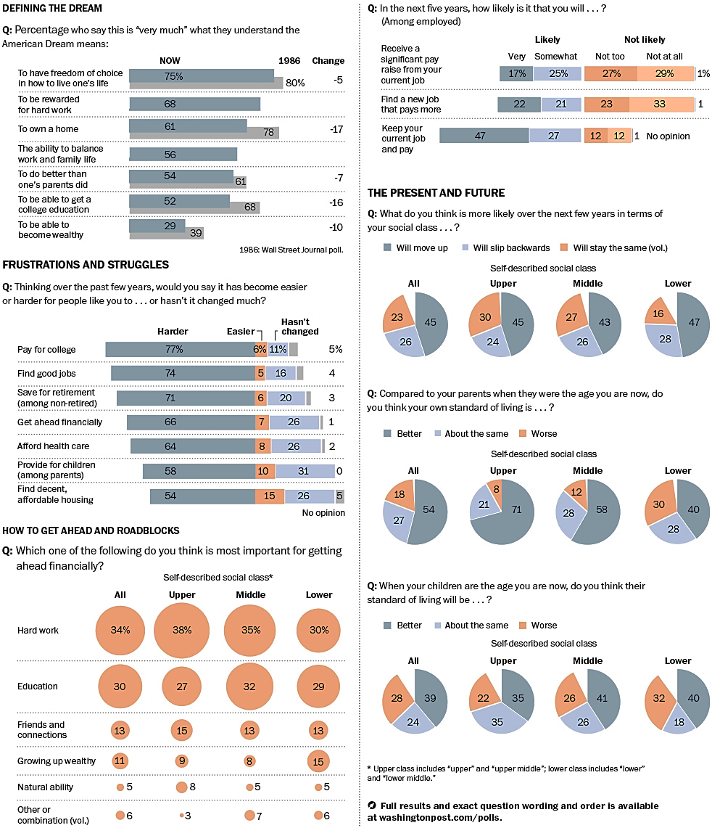

Strauss, Valerie. "Fewer People View College Education as Part of ‘American Dream’." The Washington Post. The Washington Post, 1 Oct. 2013. Web. 25 Feb. 2014. <http://www.washingtonpost.com/blogs/answer-sheet/wp/2013/10/01/fewer-people-view-college-education-as-part-of-american-dream/>.

