George Orwell: Understanding the Author
George Orwell was born Eric Arthur Blair in British India, on June 25th, 1903. While his grandfather was a member of the British gentry, his family did not have a lot of money; his father worked for the British civil service. Although Blair was born in India, he moved with his mother and sister back to England when he was very young.

Blair was often sick as a child. Lonely and imaginative, he spent a great deal of time writing and had a poem published when he was only eleven. He was sent to boarding school on a partial scholarship when he was eight. There, he was exposed to British elitism, treated badly because he was not as rich as the other students. Again he turned to books and writing, gaining a reputation as a student.

However, his family did not have enough money to send him to university. Instead, in 1922, he joined the India Imperial Police Force, and spent five years in Burma. Ashamed by what he saw as the oppression of colonial rule, he returned to England in1927 to pursue a career as a writer. During this time, he struggled to support himself and came to better understand the life of the working poor. His writing focused on the plight of this group, as well as on political criticism. At this time, he took on the pen name of George Orwell so that his work did not embarrass his family.

During the 1930’s Orwell began to identify as a socialist, and, in 1936, he joined the Spanish army to fight in their civil war against General Fransico Franco. He survived a shot to the throat and arm, as well as treason charges. He also left Spain with a lifelong fear of communism.

Years of sickness followed and Orwell turned to his writing and then worked for the BBC. In 1945 Animal Farm was published, followed by 1984 in 1949. Both brought him huge success and acclaim. However, sickness still plagued him and he succumbed to tuberculosis in 1950.

George Orwell: From “Why I Write”

The following is an excerpt from an essay entitled “Why I Write,” by Orwell. It first appeared in a magazine called The Gangrel, in 1946. Read it and write notes that you can use to write a summary in your own words, include passages that you believe are important to remember.

The Spanish war and other events in 1936-37 turned the scale and thereafter I knew where I stood. Every line of serious work that I have written since 1936 has been written, directly or indirectly, against totalitarianism and for democratic socialism, as I understand it. It seems to me nonsense, in a period like our own, to think that one can avoid writing of such subjects. Everyone writes of them in one guise or another. It is simply a question of which side one takes and what approach one follows. And the more one is conscious of one's political bias, the more chance one has of acting politically without sacrificing one's aesthetic and intellectual integrity.

What I have most wanted to do throughout the past ten years is to make political writing into an art. My starting point is always a feeling of partisanship, a sense of injustice. When I sit down to write a book, I do not say to myself, ‘I am going to produce a work of art’. I write it because there is some lie that I want to expose, some fact to which I want to draw attention, and my initial concern is to get a hearing. But I could not do the work of writing a book, or even a long magazine article, if it were not also an aesthetic experience. Anyone who cares to examine my work will see that even when it is downright propaganda it contains much that a full-time politician would consider irrelevant. I am not able, and do not want, completely to abandon the world view that I acquired in childhood. So long as I remain alive and well I shall continue to feel strongly about prose style, to love the surface of the earth, and to take a pleasure in solid objects and scraps of useless information. It is no use trying to suppress that side of myself. The job is to reconcile my ingrained likes and dislikes with the essentially public, non-individual activities that this age forces on all of us.

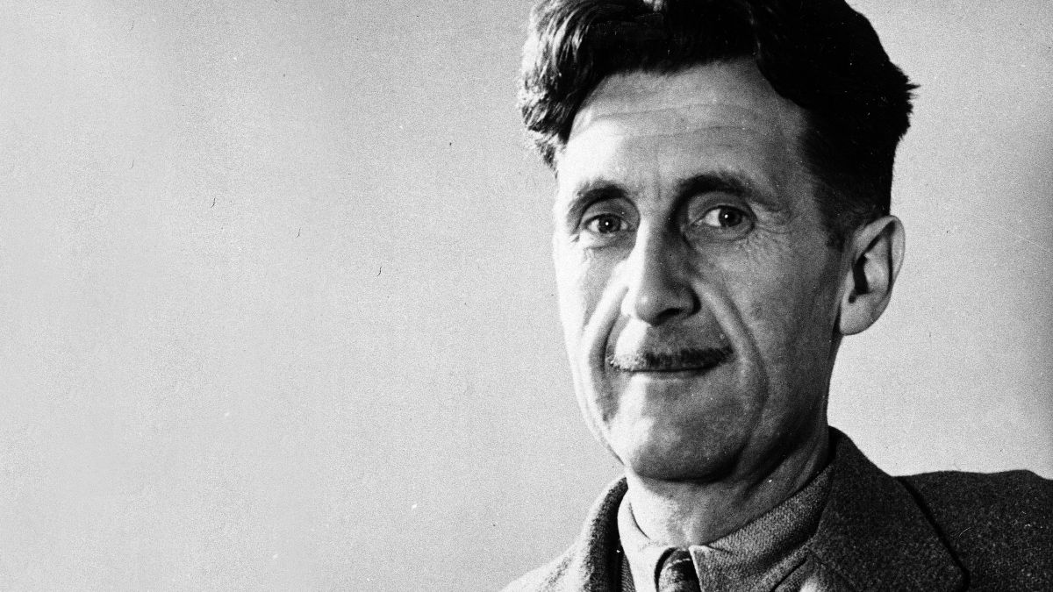
A Political Allegory
Animal Farm is an allegory about the Russian Revolution of 1917 in which the Russian Tsar, Nicholas II, was overthrown, and the world’s first communist regime was established. In his dystopian novella, Orwell creates fictional characters (who happen to be cleverly disguised as animals), who represent the actual people surrounding the events of the Russian Revolution.
In the mid-1800s the capitalist system in Europe was thriving, unfortunately, at the expense of its people. Workers of all ages (including children, since there were no labor laws against it) toiled 14-16 hours a day for meager wages in unsafe conditions. In 1847, a worker’s group called the Communist League, commissioned Karl Marx and Friedrich Engels, both German philosophers, to come up with a plan to organize and improve the worker’s situations. Their plan came to be known as The Communist Manifesto, which argues that capitalism is unstable and revolution by the underclass is inevitable. It argues that social classes and uneven distribution of wealth will not disappear without revolution.
From Marx’s ideas, for it was Engels himself who gave credit to Marx for the Manifesto, a political party called the Bolshevik Party was formed, led by Vladimir Lenin. At this time, Russia was led by Tsar Nicholas II, nicknamed Nicholas the Bloody, whose oppression and violent executions terrorized the poor, discontented populace. After a series of rebellions, in October 1917, the Bolsheviks had had enough—they led a revolution and successfully overthrew the tsarist regime and set up the new government of the Union of Soviet Socialist Republics, led by Lenin. In 1924, Lenin died, and sparked a bitter battle between Leon Trotsky, a strong follower of Marxist theory, and Joseph Stalin, head of the Communist Party. Stalin gained control, expelled Trotsky from the Communist Party, and ran him out of the country into permanent exile. In 1940, Trotsky was assassinated in Mexico.
Stalin worked to establish rapid economic and industrial growth. However, this rapid growth was not well planned, and resulted in the famine of 1932-1933, which resulted in the deaths of millions. As the new, unopposed Russian leader, Stalin gained power and strength, and used his influence to purge the country of all who opposed him. The secret police (which would later become the KGB) that he established, randomly arrested, tortured, and executed anyone who caused a problem for Stalin. During the 1930s, Stalin led the Great Purge, which led to the execution or deportation of millions, including a large number of ethnic minorities. In 1939, Stalin entered a pact with Nazi Germany. After the Nazis violated the pact in 1941, the Soviets joined the Allies to eject Hitler. This totalitarian regime dispelled freedom, forced labor, and caused general morose, and would remain such under Stalin’s control until his death in 1953. The U.S.S.R was officially dissolved in 1991.
http://cooperrussianrevolution.wikispaces.com/Animal+Farm+-+Historical+Context
Rhetorical Devices

According to Merriam-Webster, rhetoric is “the art or skill of speaking or writing formally and effectively especially as a way to persuade or influence people.” If you want to be persuasive, consider using some of these techniques in your writing and/or speaking.

The following are some common rhetorical devices:

Alliteration draws attention to a string of words through the repetition of their initial sounds.
Ex: petty politics

Analogy is a comparison between items that share a similarity, but are actually quite different. The comparison is made as a way of explaining something.
Ex: Life is a highway, with exits, rest stops and plenty of potholes.

Hyperbole emphasizes a fact through exaggeration.
Ex: It seems like an eternity since you gave me new responsibilities.

Imagery is an appeal to one or more of the senses by creating a vivid impression through the use of details and figures of speech like metaphors, simile, and personification.
Ex: The Smartphone is a Dementor, sucking out the soul of those who are addicted.

Opposites contrast two opposing ideas.
Ex: Students hate the short lunch hour; however, administration loves it as it has cut down on so many problems.

Parallelism is the repetition of specific words, phrases or clauses in a series, giving key emphasis to key words, making them memorable.
Ex: Abraham Lincoln said government was “of the people, by the people, for the people.”

Reversal makes a balanced sentence even more memorable by repeating words in reverse order.
Ex: “Ask not what your country can do for you; ask what you can do for your country.”
-JFK

Rhetorical Question is one whose answer is already known or implied.
Ex: You don’t expect me to do homework on the weekend, do you?

Sentence Fragments place emphasis on key words to create an overall effect, such as humor or suspense.
Ex: A sad day. A painful day. The day we start a week of testing.

Understatement creates the reverse effect and adds a touch of irony, by making the fact seem less important. Ex: I would be a little disappointed to hear of your death, so please put the phone away while you drive.
Propaganda Techniques
The Name Calling Approach
This approach equates a person, cause, product or candidate with a negative image or name.
The Plain Folks Approach
This approach equates the product, cause or candidate with everyday people.
The Bandwagon Approach
This technique focuses on the idea that “everybody is doing it” (buying the product, supporting the candidate, supporting the cause). It plays on people’s fear of being left out and desire to be accepted and part of the popular crowd.
The Card Stacking Approach
With the approach, the speaker buries important information “in the deck”, and builds a case for his/her cause by praising it at every opportunity. In other words, evidence that does not support the position is omitted.
The Logical Fallacies Approach
Logical fallacies include a number of techniques that illustrate a breakdown in logic. Conclusions are made based on faulty assumptions and/or facts that are not relevant. The propagandist may present something as fact, that is not fact at all, and base all further assumptions on that “fact” without providing any proof at all.
The Glittering Generalities Approach
With the approach, the speaker or writer refers to words that evoke a positive emotional response. Attractive, vague words are used, but in reality nothing of substance is said.

